SQL Assignments Set 2

The below 10 questions are based on the Emp table:

- Display the average, lowest, highest and difference in lowest and highest salaries for each department number.

select AVG(SAL) as Average ,MIN(SAL) as Minimum, MAX(SAL) as Maximum, MAX(SAL) - MIN(SAL) as Difference
from EMP

- Display the number of employees within each job.

select JOB, count(ENAME) as "No. of Employees"
from EMP
group by JOB

- Display only those jobs where the minimum salary is greater than or equal to 3000.

select job from EMP
group by JOB
having min(sal) >= 3000

- Display Deptno, total of that deptno and Grade. Grade should be A if the total is greater than 10000, else it should be B. Sort the summary output as per the highest to lowest Grade.

select DEPTNO, COUNT(DEPTNO) as "Dept Count", CASE
when sum(SAL) > 10000 then 'A'
else 'B'
end as 'Grade'
from EMP
group by DEPTNO

- Calculate and display only the average salaries paid to all those employees where the employee name starts with A and name starts with S.

select ENAME, SAL
from EMP
where (ENAME like 'A%'
or ENAME like 'S%')
and SAL >= (select avg(SAL) from EMP)

- Product exactly same output as shown below:

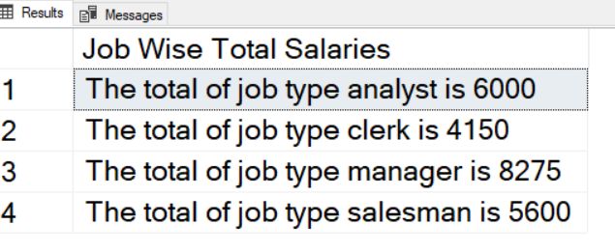

select 'The total of job type '+JOB+' is '+ cast(sum(SAL) as varchar)
from EMP
group by JOB

- Product exactly same output as shown below:

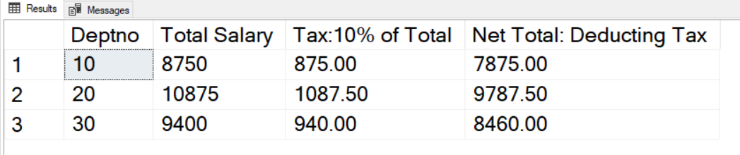

select DEPTNO, SUM(SAL), SUM(SAL)*0.1 as "Tax:10% of Total", (SUM(SAL) - SUM(SAL)*0.1) as "Net Total: Deducting tax"
from EMP
group by DEPTNO

